WEEK 3-

LAB1:

**ORM (Object-Relational Mapping)** is a programming technique that allows developers to interact with a database using object-oriented code, instead of writing raw SQL queries.ORM frameworks like **Entity Framework Core** automatically map C# **classes** to **database tables**.Each **class** represents a **table**, each **property** represents a **column**, and each **object instance** represents a **row**.

LAB2:

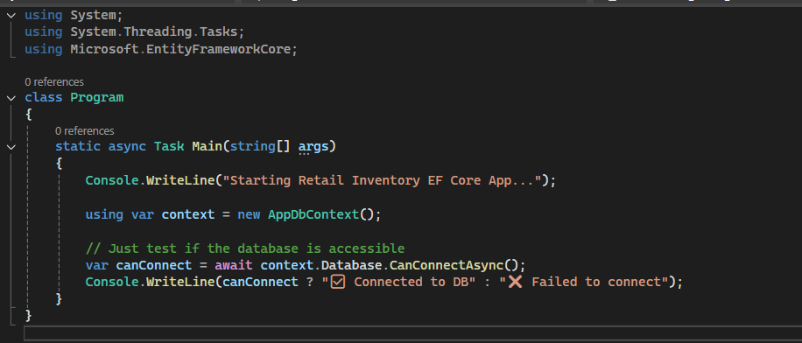

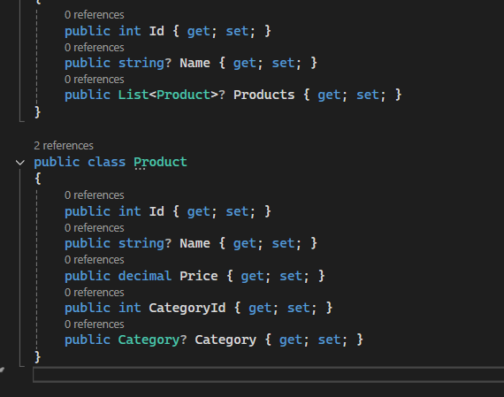

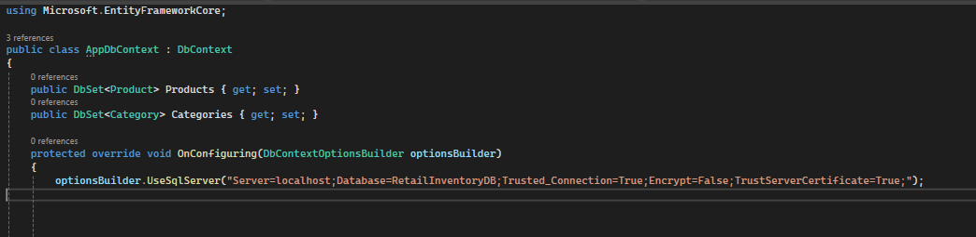

LAB3:

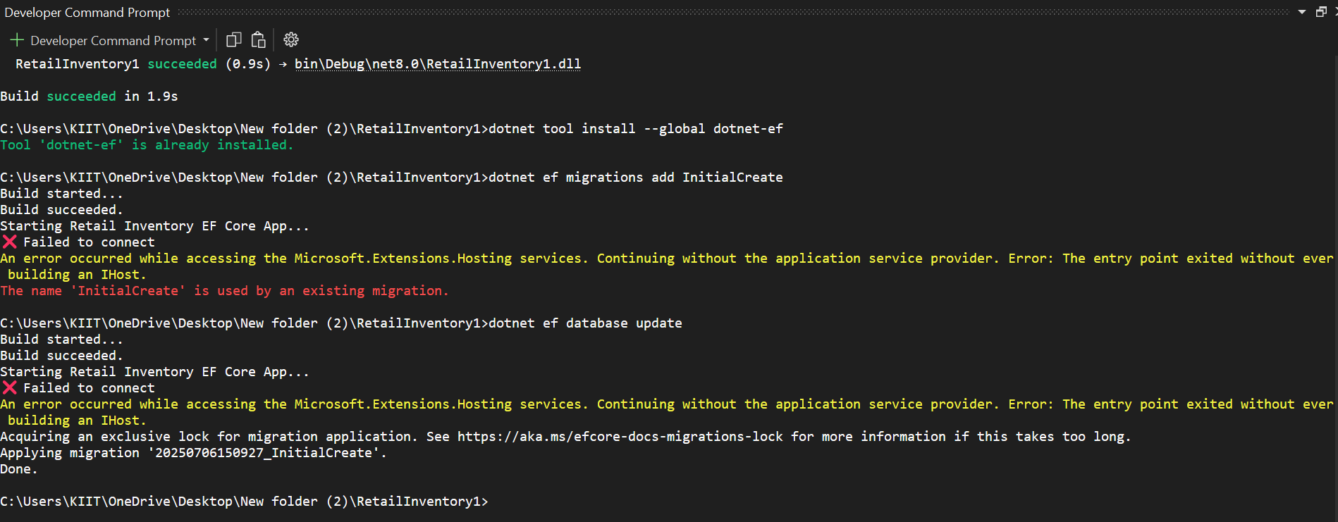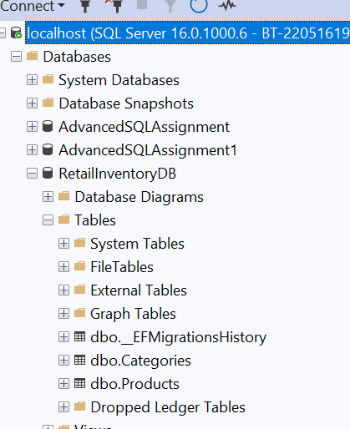

LAB4:

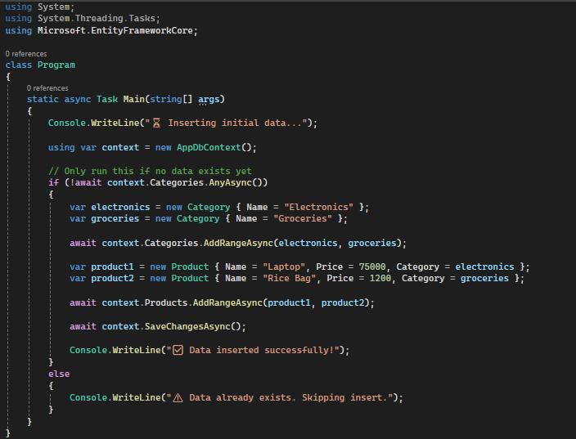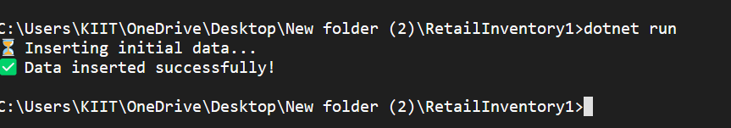



LAB5:

